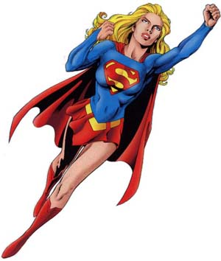
Call for Book Chapter Proposals

Heroines: Images of Women Through Literature and Popular Culture

Bob Batchelor, Maja Bajac-Carter, and Norma Jones are calling for proposals for essays to be included in an anthology focused on heroines.

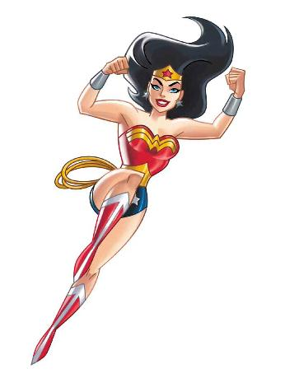
Portrayals of female heroes are often limited to roles of the sacrificial heroine (sacrificed for a cause or benefit of others) and Heidi Redeemers (overcome great obstacles by being pure and loving).

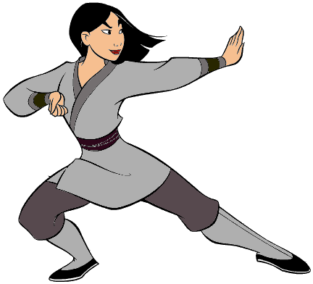
More recently, articulations of Woman Warriors (as girl power) have become more prevalent in popular culture (Xena, Amazons).

However, heroines may be more complex. In this anthology, the editors hope to further complicate and problematize portrayals of women (as heroines) in popular culture.

Essays should, in some manner, contribute to understandings of how heroines are portrayed, as well as how they might empower and/or constrain. For example, instead of conforming to male heroic norms, how does a heroine re-articulate what it means to be a woman?

The topics below provide general direction for possible chapters, but individual authors may adapt them to fit interests. The editors also welcome proposals for related topics:
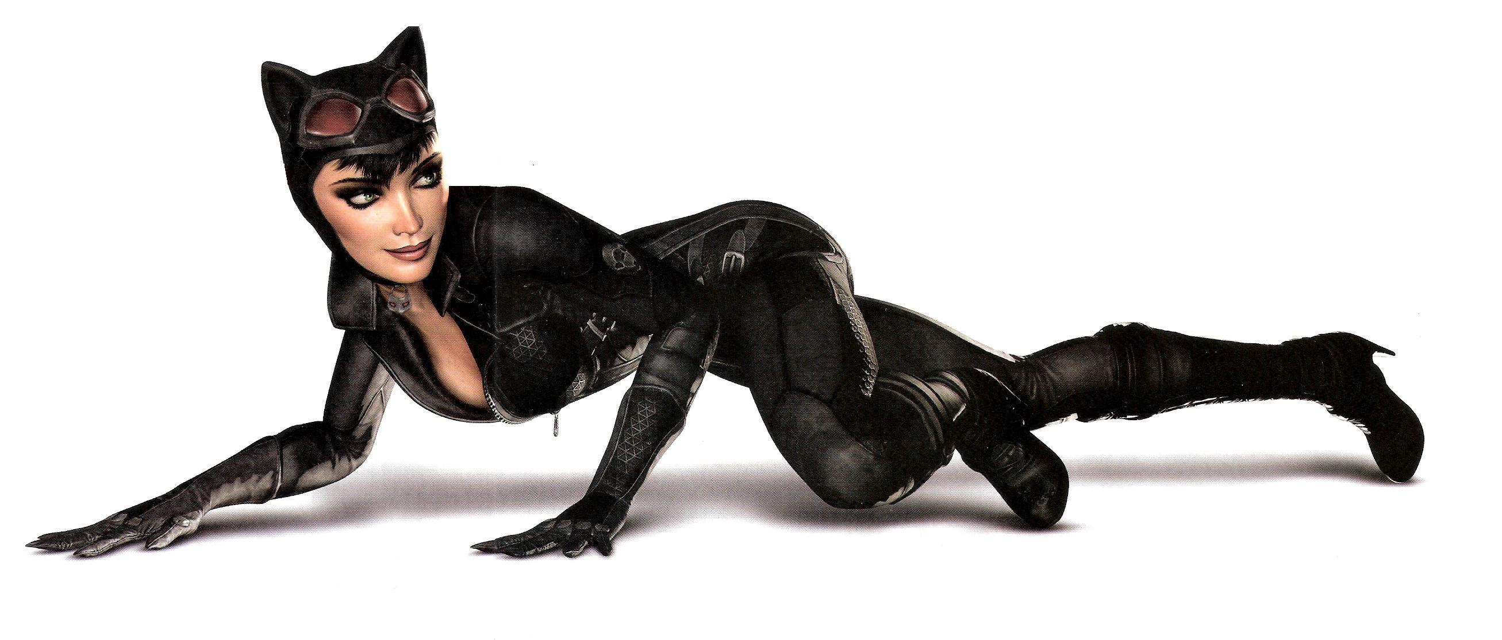
-- Heroines across cultures
-- New Fictional Heroines
-- New Women Warriors
-- Comic Book Superheroines
-- Witches and Priestesses

Please email heroine@kent.edu for further information. Please include:
-- a tentative chapter title
-- brief synopsis/proposal of your approach
-- and your C.V.
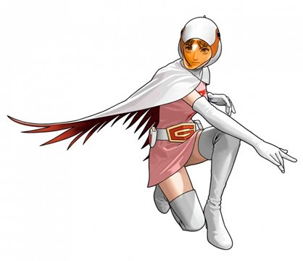

The deadline for proposals is
January 15, 2012.

