Society, Politics and Economy in Modern Turkey

A Non-Orientalist Approach to Turkey and Turkish Society

Summer 2012 / June 18 – July 7

6 Credits - INTL 499/500

You can also obtain graduate or 8 credits with a special arrangement
Center for Turkish Studies/International Studies

Instructor: Tugrul Keskin - Portland State University
University Advisor: Talip Kucukcan – Marmara University
Instructor: Nuri Tinaz – Marmara University
Saban Kardas – TOBB Economy and Technology University

Instructor: Najm al-Din Yousefi – Virginia Tech

University Advisor: Birol Yesilada - Portland State University

Participating Universities:
Portland State University - http://www.pdx.edu/
Virginia Tech University - http://www.vt.edu/
Marmara University, Istanbul – http://www.marmara.edu.tr/en
TOBB Economy and Technology University, Ankara - http://www.etu.edu.tr/
Selcuk University - http://www.selcuk.edu.tr/english/

June 18 - 30, 2012 – Istanbul
July 1 – 7, 2012 – Eskisehir, Ankara, Konya, Gocek and Izmir

Instructor: Tugrul Keskin Cell: 202-378-8606 E-mail: tugrulkeskin@pdx.edu

Assistant Professor of International and Middle Eastern Studies, Affiliated Faculty of Black Studies, Sociology and Center for Turkish Studies, Middle East Studies Coordinator (INTL)

Course Description and Objective
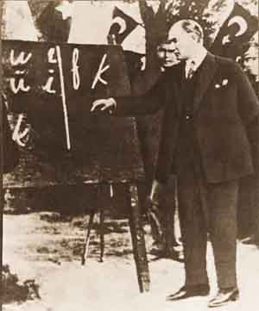
Turkey is one of the most diverse countries in the Middle East and also intersects with Europe and Asia. Its population is more than 70 million, with many different religious and ethnic groups. It is a secular state, with a unique social and political environment, shaped by its history as the multi-religious and multi-ethnic Ottoman Empire. According to the World Bank, it is one of the twenty most promising economies in the twenty first century. With more than a hundred public and 60 private universities, Turkey’s educational system has become one of the most highly prized in the Middle East.
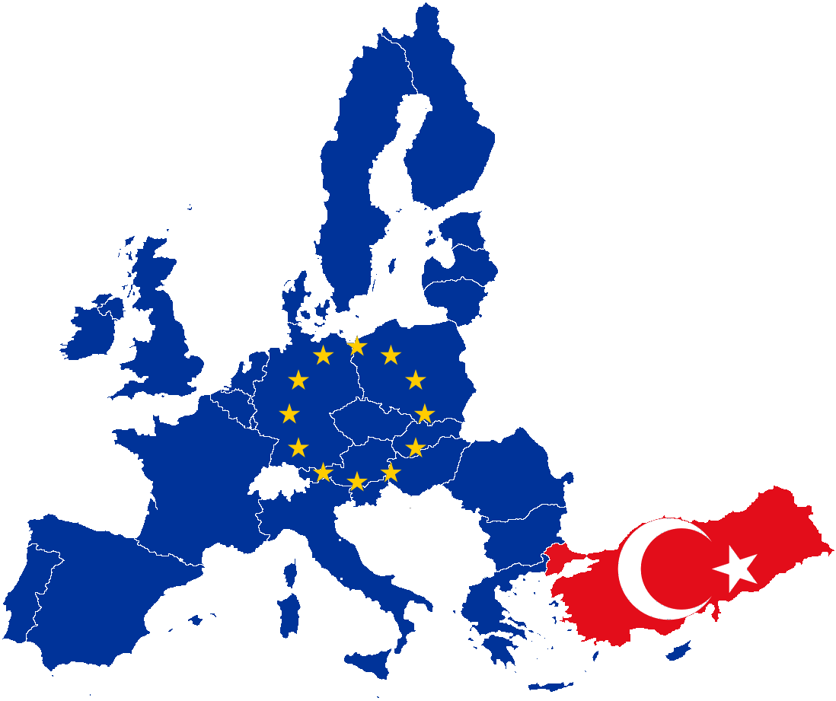
Another important aspect of Turkish life is the unique and changing role played by religion. In order to understand the current trends within Turkish society that influences the desecularization process, in addition to the likely future trends in this area, it is important to look at the historical transformation of social, political and economic structures following the establishment of the original Turkish Republic. Turkey was established through the ashes of the Ottoman Empire and was an inherently multi-ethnic society with a melting pot of religious identities that coexisted peacefully. However, in time, the Republican elite had rejected the multi-ethnic and religious identity of the Ottoman Empire and attempted to build a new nation state identity that opposed the traditional and religious values of the Ottoman Empire. The emergence of the modern Turkish Nation-State was born under these conditions. In this context, the modernization process in Turkey had been successful, however with the end of the cold war and the collapse of the Soviet Union, the neo-liberalization process led to unintended consequences for this new nation state. This included the revitalization of religious movements and the emergence of a new Islamic Bourgeoisie, a readjustment of the role of military, and a trend towards urbanization. In this course, we seek to understand and explore these trends in Turkish society based on our own interpretation from class lectures, and from meetings with political and governmental officials, and religious and community leaders.

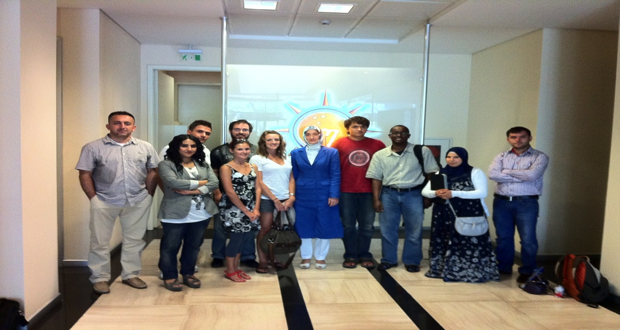
Visit to the Justice and Development Party Istanbul Office, July 2011

Learning outcomes:
- Students will become familiar with significant aspects of contemporary Turkish society, politics and the economy, and will be able to appreciate and compare the range of contemporary experiences related to these areas to other communities in the Middle East.
- Explore the socio-economic challenges faced within Turkey and understand the complex inter-connections of Turkish politics, the economy and religion by engaging in direct observation and interaction in the host country.
- Compare American society, cultural values, and perceptions with those of Turkish society, and develop an awareness of different cultural frames of reference in order to interpret events from more than one cultural lens.
- Understand the historical emergence and development of the Turkish state in the Middle East and Asia/Europe, as well as crucial factors relevant to Turkey’s position geopolitically between Europe and Asia.
- Recognize, critically analyze and respectfully defend or challenge underlying assumptions regarding the Turkish economy, politics and society in course readings and discussion.
- Identify events, actors, and trends in contemporary Turkey and their broader ramifications within the Middle East and Europe.
- Identify global issues and inter-dependencies that impact Turkey, such as its relationship to the European Union, and increasing political and strategic ties to Iran and Russia.
- Explore the role of the military, and the unique and changing role of religion in Turkish society.
- Create a bridge between PSU students and contemporary Turkish academics, politicians, religious leaders and community members, through the mutual exchange of ideas.
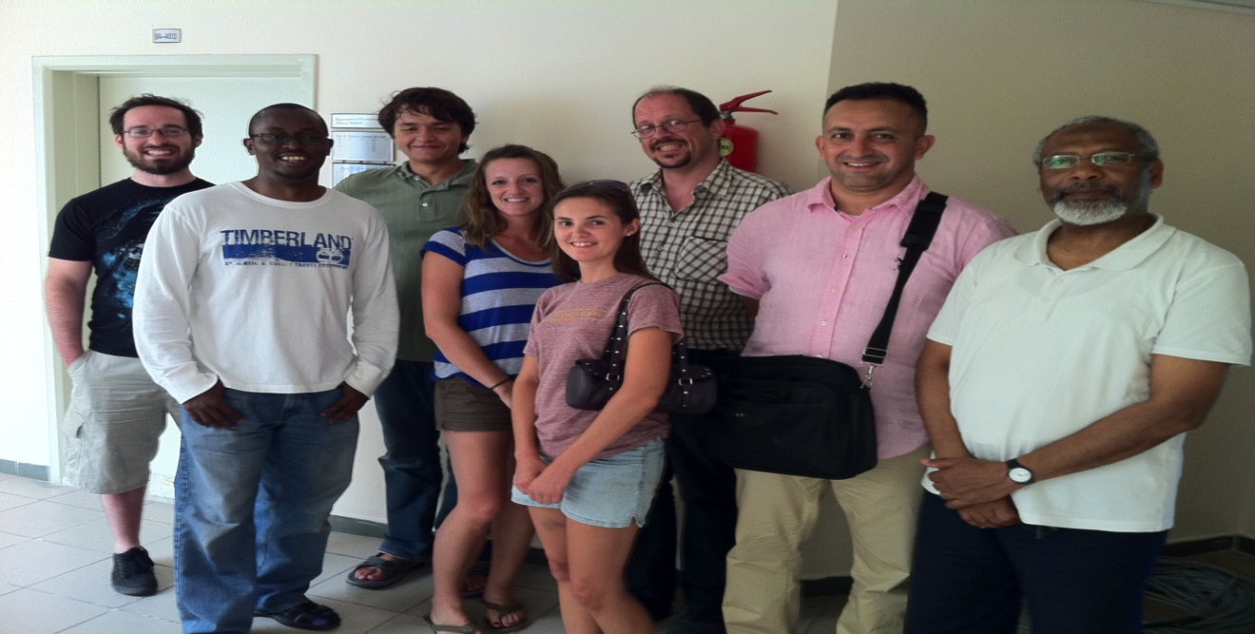
Visit to Fatih University – July 2011

Course Program (Itinerary):

Mon, June 18 | Orientation to Marmara University - (9am-12noon)  Introduction to Turkish Society, Politics and Economy – Tugrul Keskin, Portland State University (Ph.D. Virginia Tech, 2009)  New Islamic Visibilities in Public Sphere in Modern Turkey - Nuri Tinaz, Marmara University (Ph.D. University of Warwick, 2004); nuri.tinaz@isam.org.tr  - Afternoon Visit to the Grand Bazaar and Suleymaniye Mosque  - Afternoon Visit to the Istanbul Museum of the History of Science and Technology in Islam - http://www.ibttm.org/ENG/index.html
Tue. June 19 | Religion in Turkish Society (9am-12noon)  Islamic Movements in Turkey - Joshua Hendrick, Loyola University of Maryland (Ph.D. University of California Santa Cruz, 2009) jdhendrick@loyola.edu  - Afternoon Visit to ISAM (Center for Islamic Studies) with Dr. Nuri Tinaz http://www.isam.org.tr/  - Visit to Sehir University  http://www.sehir.edu.tr/en/Pages/Homepage.aspx
Wed. June 20 | Religion, Society and Diaspora (9am-12noon)  Between Europe and Islam: Muslim Immigrants in Europe - Tahir Abbas from Fatih University (Ph.D. University of Warwick, 1997) tahir_abbas@hotmail.co.uk  - Visiting to Rifat Bali who is an Independent Researcher and Writer working on religious minorities; rifat.bali@gmail.com  Jews in Turkey: Ethno-religious Minority in Modern Turkish Republic  - Afternoon Visit to the Turkish World Research Foundation –Meeting with Professor Turan Yazgan http://www.turan.org.tr/
Th. June 21 | Religion and Education (10am-12noon)  Science and Philosophy Education in Turkey between “universalism” and Turkish/Islamic identity - Rainer Broemer from Fatih University Istanbul (PhD Goettingen University 2008); rbromer@fatih.edu.tr  - Afternoon Visit to Fatih University - http://www.fatih.edu.tr/?&language=EN  - Afternoon Visit to Yenisafak Daily Newspaper (http://yenisafak.com.tr/English/?t=22.07.2011) and meeting with Ibrahim Karagul, Journalist. ikaragul@yenisafak.com.tr  http://yenisafak.com.tr/Yazarlar/?s=1&y=IbrahimKaragul
Fr. June 22 | Politics and Society (9am-12noon)  A Brief History of CHP - Yunus Emre, Istanbul Kultur University and former president of CHP youth organization. y.emre@iku.edu.tr  - Afternoon Visit to Republicans People’s Party (CHP) Istanbul Office and Social Democracy Foundation. http://www.chp.org.tr/en/  - Nurhayat Kizilkan - nurhayat.kizilkan@gmail.com  Visit to Armenian Association in Kurtulus/Sisli  http://wowturkey.com/forum/viewtopic.php?t=49711
Sat. June 23 | Free
Sun. June 24 | Visit to Cerrahi Islamic Order – 8:00 PM  http://www.jerrahi.org/en/content/about  http://www.youtube.com/watch?v=Kn57D7UXIBg&feature=related  http://www.youtube.com/watch?v=YonQ_IYU7HM  http://7kubbe.net/31_31049_cerrahi-mevlevi-zikir-sema-dhikr-jerrahi-sufi-order.html
Mon. June 25 | Nationalism and Turkish Politics (9am-12noon)  A Brief History of Turkish Nationalist Movement – Tugrul Keskin  tugrulkeskin@pdx.edu  - Afternoon Visit to Nationalist Movement Party (MHP) and Ulku Ocaklari (Idealist Association – PanTurkist Movement) Istanbul Office http://www.mhp.org.tr/  - Afternoon Visit to Yesiller Partisi (Green Party)  http://www.yesiller.org/
Tue. June 26 | Foreign Policy and Turkish Politics (10am-12noon)  Transformation of Turkish Foreign Policy - Birol Baskan, Georgetown University (Ph.D., Northwestern University, 2008) birolbaskan@yahoo.com  - Afternoon Visit to Turkish Communist Party (TKP) Istanbul Office –Kadikoy - http://tkp.org.tr/
Wed. June 27 | Middle East and Turkish Politics (9am-12noon)  Islam and Society in the Middle East - Najma Yousefi, Virginia Tech (Ph.D. Virginia Tech, 2010) nyousefi@vt.edu  - Afternoon Visit to Turkish Worker’s Party (IP) Istanbul Office  - Visit to Bahcesehir University and meeting with Professor Nilufer Narli http://www.bahcesehir.edu.tr/index/index
Th. June 28 | Alevi and Bektashi Community and Turkish Politics (9am-12noon)  Alevi-Bektashi Community in Modern Turkish Republic - Ayfer Karakaya-Stump, the College of William and Mary (Ph.D. Harvard University, 2008) ak732@cornell.edu  - Afternoon visit to the Sahkulu Alevi Community or Karacaahmet Dergahi - http://www.sahkulu.com/
Fr. June 29 | Politics and Economy (9am-12noon)  Turkey and European Union – Beken Saatcioglu, Bosphorus University (Ph.D. University of Virginia, 2010)  bs5t@virginia.edu  - Afternoon Visit to Justice Development Party (AK Party) Istanbul Office - Erkan Kandemir and Merve Tugba  - Afternoon Visit to the Independent Industrialists and Businessmen’s Association (MUSIAD) office in Istanbul
Sat. June 30 | Free
Sun. July 1 | Leaving from Istanbul for Ankara
Mon. July 2 | Social and Economic Transformations in Anadolu  - Visit to Eskisehir and Anadolu University  https://www.anadolu.edu.tr/en/
Tue. July 3 | Turkish Foreign Policy (9am-12noon)  Turkish Foreign Policy and Arab Spring - Saban Kardas TOBB Economy and Technology University (Ph.D. University of Utah, 2009) sabankardas@gmail.com  - Afternoon Visit to Anitkabir - http://www.anitkabir.org/  - Grand General assembly of Turkey - http://www.tbmm.gov.tr/english/english.htm  - SETA (Foundation for Political Economic and Social Research - http://www.setav.org/en.aspx
Wed. July 4 | Religion and Society (9am-12noon)  - Visit to Konya and Selcuk University  http://www.selcuk.edu.tr/english/ or http://www.selcuk.edu.tr/  - Afternoon Visit to Mevlana Museum  http://tr.wikipedia.org/wiki/Mevlana_M%C3%BCzesi
Th. July 5 | Visit to Gocek, Mugla Province  - Yacht Tour in the Gocek (Optional)  http://www.gocek.org.tr/eng/
Fr. July 6 | Visit to Izmir  - Afternoon Visit to Yasar University  http://www.yasar.edu.tr/en/
Sat. July 7 | Visiting Bursa  http://en.wikipedia.org/wiki/Bursa  Arriving Istanbul
Sun. July 8 | Departure

Location:
Istanbul is a metropolis that extends over Asia and Europe, which form the eastern and western parts of the city with the strait of Bosporus dividing them. The European side is further divided into two parts with the Golden Horn separating the old city in the south from the business and entertainment districts in the north. The city is home to more than ten million people and has a history that goes back to the Paleolithic period. Its urban origins go back to seventh century BCE when Greek colonists settled there and established the city of Byzantium. The Roman Emperor Constantine decided to move the capital of his empire to Byzantium in the first half of the fourth century and expanded the city, hence Constantinople, or the city of Constantine. After the city fell to the Ottomans in 1453, it continued to be an imperial capital under the Ottomans until 1922 when the last Ottoman sultan fled the city. Today it is the most populous city of Turkey and a major center of international business, culture, entertainment, and tourism with a diverse population that represents all regions of Turkey.

Classrooms and Housing:
The headquarters of the Portland State University Abroad Program in Istanbul will be at the downtown campus of the Marmara University – Institute of Middle East Studies in Sultanahmet, Istanbul which is right at the downtown of Istanbul:
http://oae.marmara.edu.tr/?&dil=en

Accommodation:
- Yenisaray Hotel
http://www.yenisarayotel.com/ - Approximately 45 Dollars a night, include breakfast - Situated in the heart of Uskudar historic district, just steps from the Ferry station. Yenisaray Hotel offers elegant accommodation and beautiful views of the Marmara Sea. Yenisaray Hotel's prime location is ideal for guests touring the historic sites. Traditional Turkish hospitality and attentive service ensure a pleasant stay.
- The Bosphorus Apart Hotel
http://www.thebosphorusaparts.com/ - 120 to 170 Turkish liras ($65 to $85) based on double occupancy. This is a brand new apart hotel with a private kitchen and bath. Breakfast is not included.

University Location:
Marmara University
Küçük Ayasofya Mh.
34122 Istanbul/Istanbul, Turkey
http://maps.google.com/maps?q=K%C3%BC%C3%A7%C3%BCk+Ayasofya+Mh.+34122+Istanbul/Istanbul,+Turkey&oe=utf-8&rls=org.mozilla:en-US:official&client=firefox-a&um=1&ie=UTF-8&hq=&hnear=K%C3%BC%C3%A7%C3%BCk+Ayasofya+Mh.,+Istanbul/Istanbul+Province,+Turkey&gl=us&ei=q7ZFTba_L5G6sQOj8ZGqCg&sa=X&oi=geocode_result&ct=image&resnum=1&ved=0CBYQ8gEwAA

Participating Faculty:
Marmara, Loyola University of Maryland, Qatar, Georgetown, Michigan, Virginia Tech, Sakarya Universities and The College of William and Mary faculty members will lecture on selected topics related to their areas of expertise:
- Ali Arslan - Sakarya University (Ph.D. Bosphorus University)
- Ayfer Karakaya - Stump - The College of William and Mary (Ph.D. Harvard University, 2008)
- Beken Saatcioglu – Bosphorus University (Ph.D. University of Virginia, 2010)
- Birol Baskan - Georgetown University (Ph.D., Northwestern University, 2010)
- Joshua Hendrick – Loyola University of Maryland (Ph.D., University of California Santa Cruz, 2009)
- Najm al-Din Yousefi – Virginia Tech (Ph.D. Virginia Tech, 2010)
- Nuri Tinaz - Marmara University (Ph.D. University of Warwick, 2003)
- Rainer Bromer – Fatih University (Ph.D. Georg August University Göttingen, Germany, 2008)
- Rifat Bali is an Independent Researcher and Writer working on religious minorities.
- Saban Kardas – TOBB Economy and Technology University (Ph.D University of Utah)
- Tahir Abbas – Fatih University (Ph.D. University of Warwick, 2003)
- Talip Kucukcan - Marmara University (Ph.D. University of Warwick, 1997)
- Tugrul Keskin – Portland State University (Ph.D. Virginia Tech, 2009)

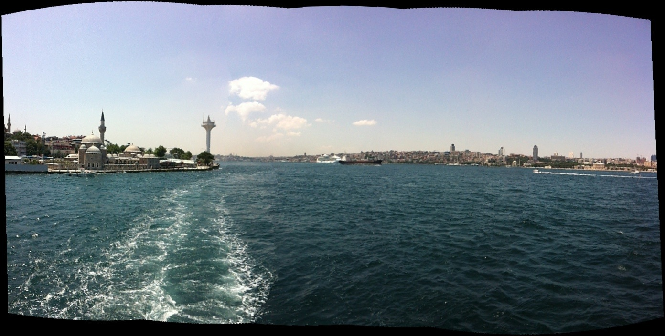
Recommended Texts:
- Ali Carkoglu and E. Kalaycioglu (2009). The Rising Tide of Conservatism in Turkey. New York, Palgrave/MacMillan.
- Bernard Lewis, The Emergence of Modern Turkey. Oxford University Press, 2001.
- Turkish Studies, Volume 11 Issue 1 2010: Special Issue: Islamization of Turkey under AKP Rule. Birol Yesilada and Barry Rubin. Routledge Press.
- Erik J. Zurcher. 2005. Turkey: A Modern History, Revised Edition. New York: I.B Tairus&Co Ltd.
- Ersin Kalaycioglu, Turkish Dynamics: Bridge Across Troubled Lands. Palgrave Macmillan, 2005.
- Hakan M. Yavuz 2003. Islamic Political Identity in Turkey. New York, NY: Oxford University Press.
- Hakan M. Yavuz. 2006. The Emergence of A New Turkey: Democracy and The Ak Party. Salt Lake City, UT: The University of Utah Press.
- Graham Fuller. 2007. New Turkish Republic: Turkey As a Pivotal State in the Muslim World. Washington, DC: United States Institute of Peace Press.
- Stephen Kinzer. 2008. Crescent and Star: Turkey Between Two Worlds. New York, NY: Farrar, Straus and Giroux.

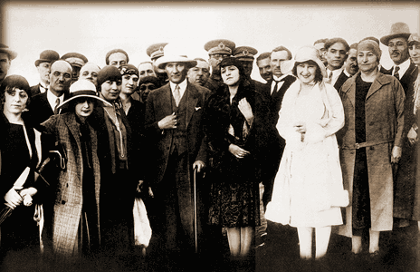

Course Philosophy:
The goal of this course is to enable students to write a theoretically guided and empirically rooted research paper. I expect you to become familiar with the social, political and economic underpinnings of Contemporary Turkey.

The success of this course depends on your continued and sustained reading and participation. The course will be based on a four-dimensional method of learning, and this includes inquiry and critical thinking; communication; the diversity of human experience; and ethics and social responsibility. First, I would like you to critically analyze what you learn in this class or have learned so far through the media and education, because in today’s world, truth is a relative concept. Throughout human history, critical thinking is the one of the most important factors that has contributed to human development. In order to become active, self-motivated, empowered learners and future leaders, you will need to have the ability to think critically, and therefore your criticism, feedback and suggestions are necessary. Second, I would like you to enhance your writing and oral communication skills in this course. Therefore, it is important to clearly elaborate your arguments in the class discussion as well as in the written assignments.
Third, we are each part of the human mosaic, and all have different experiences based on our social, political and economic differences. We can all learn from and respect each other and benefit from our diversity. Please try to learn from and understand those with different perspectives than you. Lastly, we need to learn that we are all part of this intellectual community and larger society, and all have social and ethical responsibilities to our family, community, classmates, and humanity. We live in a globalized world and therefore, we need to be aware of events in our community, and the world today. In order to enhance our knowledge, we must critically examine our social, political and economic environment in order to apply this knowledge to our experience.

Course Requirements

To prevent confusion later, please read the following information:

Daily Reflection Notes (10): This will include open book notes that will describe what you have learned in class from course lectures and readings and site visits each day. The daily reflection notes should be at least one page long and single-spaced. Font size should be Times New Roman, 12 point. The due date for each paper is Monday by 11:59 PM. Criteria: If your paper is less than a page in length, or late, you will loose 2 points.

Newspaper Articles: During this course, you can bring 6 newspaper articles (3 articles each week for the first two weeks) from Newspapers related with our class subjects. You cannot bring more than two articles in the same week. You will have to summarize these articles in class. You will find the recommended newspapers on the course website (D2L) under the external links section.

This option is for graduate students and 8 credits (additional 2 credits)
Final Paper: You will choose a topic in Contemporary Turkish Studies and you will analyze and explain it within the theoretical framework of this class. I must approve your topic and plan ahead of time. The final paper is a short empirical or theoretical paper of at least 15 pages in length, Times New Roman font, 12 point, doubled spaced, and on a focused topic that relates directly to this course.

Format: ASA citation and bibliography format will be followed for all course assignments. All work should adhere to the guidelines published by the American Sociological Association (ASA) at:
http://www.asanet.org/cs/root/topnav/sociology_depts/quick_style_guide.
This is not a definitive source, but is a Quick Guide provided by ASA.

Attendance: Regular attendance is one of the important parameters to successful completion of the course requirements.

Grades: Your grade for this course will be based on performance on the following components, shown with their dates and respective weights:

Item Date Weight (%)

10 Reflection Notes First Two Weeks 70.0
Participation/ Attendance 18.0
Newspaper Articles 12.0
Final Paper (Please see above for this requirement) 30.0

The grading system in this class is as follows:

A 95-100
A- 90-94
B+ 86-89
B 85
B- 80-84
C+ 76-79
C 75
C- 70-74
D+ 66-69
D 65
D- 60-64
F (Failure)

Coming late to class: Late comers will not be accepted to class, so be on time. If you are late for a class, please do not disturb your classmates and me and do not come at all. Please also do not send an email or call me regarding your class attendance. If there is a medical need, bring a letter from a doctor. Whatever the reason is, if you cannot come to class, this is your responsibility. If you miss more than 2 classes, you will not receive an attendance grade.

Laptop and cell phone policy: If you need your laptop in class to take notes, please let me know. Otherwise I will assume that you are surfing the Internet during my lectures. Please turn your cell phone off before you come to class. If you use the Internet or your cell phone during class, you will be asked to leave.

Disabilities: Please let me know if you have any disabilities relevant to your involvement in this class, so that I can make appropriate adjustments. Contact Disability Resource Center at Portland State University 435 Smith Memorial Student Union, 1825 SW Broadway Portland, OR 97201 - Phone: (503) 725-4150 - Fax: (503) 725-4103 - TTY or Relay: (503) 725-6504. Email: drc@pdx.edu, if you think you may have a class related disability for which you need counseling and certification. Following is the link to the Disability Resource Center, and all related matters will be kept in strict confidence:
http://www.pdx.edu/uasc/disability-resource-center.

PSU Student Code of Conduct: I will enforce the Student Code of Conduct strictly in this course. Be familiar with it. Unless specifically stated otherwise, you should complete any work for this course without assistance from others. Cheating, plagiarism, falsifications and attempts at any of these acts in connection with any work for this course are violation of the Student Code of Conduct.
(2) All forms of academic dishonesty, cheating, and fraud, including but not limited to: (a) plagiarism, which includes, but is not limited to, word for word copying, using borrowed words or phrases from original text into new patterns without attribution, or paraphrasing another writer's ideas; (b) The buying and selling of all or any portion of course assignments and research papers; (c) Performing academic assignments (including tests and examinations) for other persons; (d) Unauthorized disclosure and receipt of academic information; and (e) Falsification of research data.
http://www.pdx.edu/dos/conductcode

Additional Remarks: If you have difficulty with the course, please schedule a time to discuss your concerns with me, to help you get back on track.

READINGS:
First Week:
- Social and Political Transformations of Modern Turkish Society – Tugrul Keskin (Available on D2L)
- Orientalism in Modern Turkish Studies - Tugrul Keskin (Available on D2L)
- Nationalist Movement Party (MHP): From Pan-Turkism to Localization – Tugrul Keskin (Available on D2L)
- Sacralization of the State and Secular Nationalism: Foundations of Civil Religion in Turkey – Talip Kucukcan - George Washington International Law Review, 2011. (Available on D2L)
- Revisiting the Role of Credible EU Membership Conditionality for EU Compliance: The Turkish Case - Beken Saatcioglu (Available on D2L)
- Religion and ethnicity in the construction of official ideology in Republican Turkey – Omer Caha, Metin Toprak and Nasuh Uslu - Muslim World, Jan 2010, Vol. 100 Issue 1, p33-44; , 12p (Available on D2L)
Second Week
- Changing Values in Turkey: Religiosity and Tolerance in Comparative Perspective – Birol Yesilada and Peter Noordijk - Turkish Studies Vol. 11, No. 1, 103–123, March 2010. (Available on D2L)
- Justice and Development Party at the Helm: Resurgence of Islam or Restitution of the Right-of-Center Predominant Party? – Ersin Kalaycioglu - Turkish Studies Vol. 11, No. 1, 29–44, March 2010. (Available on D2L)
- Transformation of Turkish Islamism and the Rise of the Justice and Development Party – Mustafa Sen - Turkish Studies Vol. 11, No. 1, 29–44, March 2010. (Available on D2L)

Other articles will be provided…

Third Week:
- Turkey: Redrawing the Middle East Map Or Building Sandcastles? – Saban Kardas - Middle East Policy, Vol. XVII, No. 1, Spring 2010. (Available on D2L)
- NATO's Islamists: Hegemony and Americanization in Turkey - Cihan Tugal - New Left Review 44, March-April 2007. http://newleftreview.org/?view=2657
- A Paradigm Shift in Turkish Foreign Policy: Transition and Challenges – Ahmet Sozen - Turkish Studies Vol. 11, No. 1, 103–123, March 2010. (Available on D2L)

Other articles will be provided…

